## Reports Menu/HIPAA/HIPAA Inspection Log:

1)Request:

🡪The initial page after Hipaa inspection log click event is:

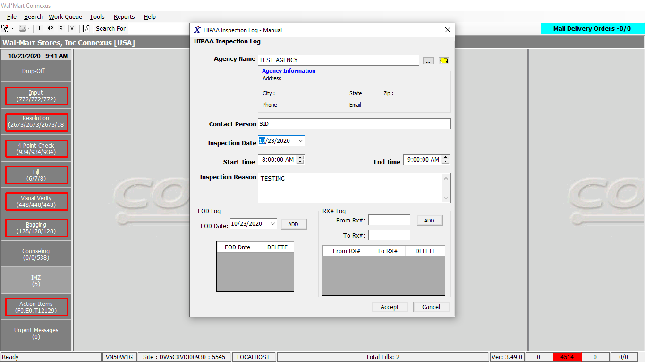

🡪The Agency name must be verified. That is either it should already be in the data base or the new agency Should be created by entering the agency details. Refer the below snapshots.

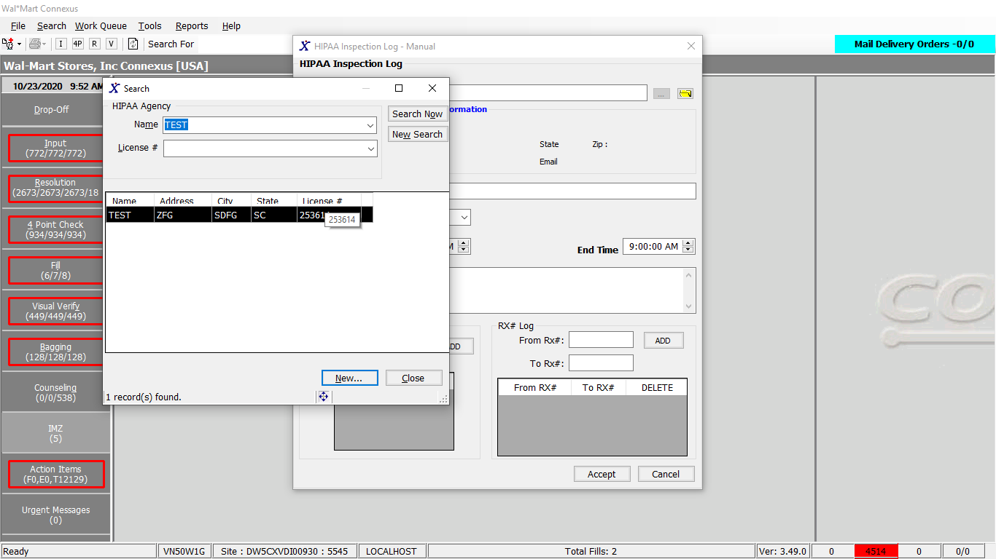

Note: The search criteria for agency are “Name” and “LicenceId”.

🡪If the log is for new agency then it should be created.

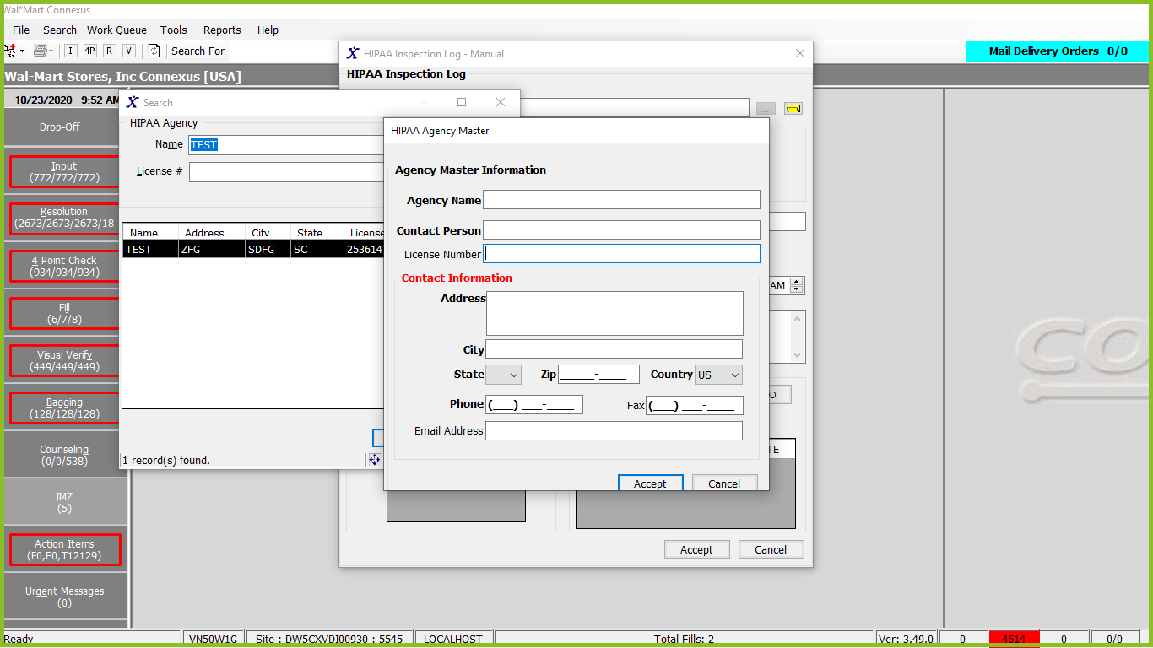

2)Miscellaneous points:

🡪The EOD date and Rx range are optional. If they are entered they must also be saved into database.

3)Response: The response of after “Accept” click event will be successful insertion message.

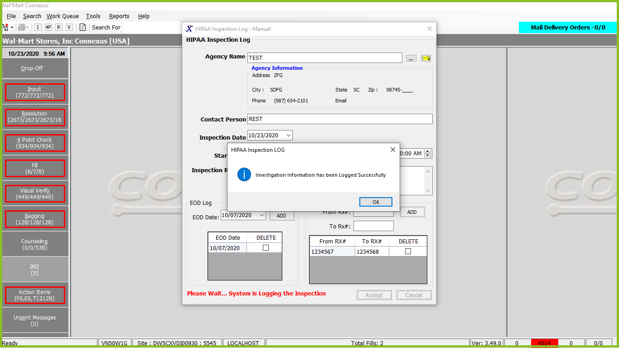

3)DAL method and stored procedure:

Public Function InsertInspectionTransactionLog(ByVal siteId As Integer,

ByVal transactionLogInfo As InspectionTransactionLogBE,

ByVal rxValue As String, ByVal eodValue As String,

ByVal inspectionValue As String) As Integer Implements IHIPAADAL.InsertInspectionTransactionLog

Using tracer As New Tracer(ConnexusCommonConstants.ConnexusTracer)

Dim paramList As New List(Of DbParameter)

paramList.AddParameter(DbType.Int32, transactionLogInfo.RequestingPartyId)

paramList.AddParameter(DbType.Int16, transactionLogInfo.RequestorTypeCode)

paramList.AddParameter(DbType.DateTime, transactionLogInfo.RequestTS)

paramList.AddParameter(DbType.String, transactionLogInfo.RequestorName)

paramList.AddParameter(DbType.DateTime, transactionLogInfo.InspectionStartTS)

paramList.AddParameter(DbType.DateTime, transactionLogInfo.InspectionEndTS)

paramList.AddParameter(DbType.DateTime, transactionLogInfo.DisclosureTS)

paramList.AddParameter(DbType.String, transactionLogInfo.UserId)

paramList.AddParameter(DbType.String, transactionLogInfo.RequestText)

paramList.AddParameter(DbType.Int16, transactionLogInfo.RequestTypeCode)

paramList.AddParameter(DbType.String, eodValue)

If String.IsNullOrEmpty(rxValue) Then

paramList.AddParameter(DbType.String, Nothing)

Else

paramList.AddParameter(DbType.String, rxValue)

End If

If String.IsNullOrEmpty(inspectionValue) Then

paramList.AddParameter(DbType.String, Nothing)

Else

paramList.AddParameter(DbType.String, inspectionValue)

End If

Dim inspectionTransactionLog As Integer

Using dr As IDataReader = ExecuteReader(DatabaseEnum.rx21c, siteId, HipaaQueries.InsertInspectionTransactionLogCall, paramList)

If dr.Read Then

inspectionTransactionLog = dr.GetValueOrDefault(Of Int32)(0)

End If

End Using

Return inspectionTransactionLog

End Using

End Function

--------------End of function-------------------------------------------------------------------

🡪The Following procedure has been called in the above highlighted line.

Friend Const InsertInspectionTransactionLogCall As String = "{Call insertinspectiontranslog_new(?,?,?,?,?,?,?,?,?,?,?,?,?)}"

Procedure: insertinspectiontranslog_new

**CREATE** **PROCEDURE** insertinspectiontranslog_new(irqst_part_id **integer**,

srqstor_type_cd **smallint**,

dtrequest_ts **datetime** **year** **to** **second**,

crequestor_namechar(30),

dtinspection_start_ts **datetime** **year** **to** **second**,

dtinspection_end_ts **datetime** **year** **to** **second**,

dtdisclosure_ts **datetime** **year** **to** **second**,

ccreate_userid **char**(10),crequest_txt **varchar**(255),

sreport_type_code **smallint**,

cSQLEOD LIST(**lvarchar** **not** **null**),

cSQLRX **lvarchar**,

CSQLINSPECTIONTIME **lvarchar**,

iDebug **smallint** **DEFAULT** 0)**returning** **integer** ;

**define** in_trans **smallint**;

**define** sql_err_code **integer**;

**define** isam_err_code **integer**;

**define** err_desc **varchar**(255);

**define** ihipaa_tran_id **integer**;

**define** lstmt **lvarchar**;

**define** lRXRetval **lvarchar**;

**define** lINSPECTIONTIMERetVal **lvarchar**;

**define** lEODRetVal **lvarchar**;

**define** lTmpRetval **lvarchar**;

**define** lSQLEOD **lvarchar**;

**define** lExecEODSQL **lvarchar**;

**define** CONST_SUBJ_AGENCY **integer**;

**define** CONST_WORK_SEQNO **integer**;

**define** CONST_FAX_SEQNO **integer**;

**define** lRemedyRqstTxt **lvarchar**;

-- SCCSID: @(#) name:InsertInspectionTransLog_NEW.sql stored_procedure scid=version:1.11 date_modified:05/03/08 derived_by: __PWR_CHG_USER__

**on** **exception** **set** sql_err_code,isam_err_code,err_desc

**if** in_trans=0

**then**

**rollback** **work**;

**return** -1;

**end** **if**

**raise** **exception** sql_err_code,isam_err_code,err_desc;

**end** **exception**;

**on** **exception** **in** (-958)

**let** in_trans=0;

**delete** **from** hirqr_tmp;

**end** **exception** **with** **resume**;

**on** **exception** **in** (-316)

**let** in_trans=0;

**drop** **index** hirqr_tmp_idx;

**CREATE** **INDEX** hirqr_tmp_idx **ON** hirqr_tmp(rx_id);

**end** **exception** **with** **resume**;

**on** **exception** **in** (-535,-744)

**let** in_trans=1;

**end** **exception** **with** **resume**;

IFiDebug = 1 **THEN**

**SET** **DEBUG** **FILE** **TO** '/tmp/insertinspectiontranslog_new.trace';

**TRACE** **ON**;

**END** **IF**

**let** in_trans=1;

**CREATE** **TEMP** **TABLE** hirqr_tmp

(rx_id **INTEGER** **not** **null**,rx_version_seq_nbr **smallint** **not** **null**)

**WITH** **NO** **LOG**;

**LET** CONST_SUBJ_AGENCY =308;

**LET** CONST_WORK_SEQNO = 2;

**LET** CONST_FAX_SEQNO = 3;

**LET** lRemedyRqstTxt = "";

**LET** lstmt = "";

**LET** lSQLEOD = ' select distinct rx.rx_id, rx.rx_version_seq_nbr ' ;

**LET** lSQLEOD = lSQLEOD || ' ' || ' FROM rx_fill rxf, rx rx, patient pat,prescriber pres, rx_input rxi, ';

**LET** lSQLEOD = lSQLEOD || ' ' || ' OUTER rx_order_detail rod, OUTER subject_address sa, ';

**LET** lSQLEOD = lSQLEOD || ' ' || 'OUTER (prescriber_clinic pcli, OUTER subject_address sa1),OUTER prescriber_license presl, ';

**LET** lSQLEOD = lSQLEOD || ' ' || 'OUTER prescriber_license prestate, OUTER subject_comm sbjc, ';

--- LET lSQLEOD = lSQLEOD || ' ' || 'OUTER pharmacy_offering:pharmacy_product pp, OUTER Pharmacy_code_txt pct ';

**LET** lSQLEOD= lSQLEOD || ' ' || 'OUTER pharmacy_offering:pharmacy_product pp, OUTER daw_text pct ';

**LET** lSQLEOD = lSQLEOD || ' ' || 'Where rxf.rx_id = rx.rx_id And rxf.fill_type_code <> 7003 ';

**LET** lSQLEOD = lSQLEOD || ' ' || 'AND rxf.rx_version_seq_nbr =rx.rx_version_seq_nbr AND rx.input_id = rxi.input_id';

**LET** lSQLEOD = lSQLEOD || ' ' || 'AND rx.rx_version_seq_nbr = 1 AND rxi.input_source_code = 3800 ';

**LET** lSQLEOD = lSQLEOD || ' ' || 'AND rx.prescriber_id = pres.prescriber_id AND rx.prescriber_id = presl.prescriber_id ';

-- LET lSQLEOD = lSQLEOD || ' ' || 'AND presl.license_type_code = 800 AND rx.prescriber_id = prestate.prescriber_id ';

**LET** lSQLEOD = lSQLEOD || ' ' || 'AND presl.license_type_code in (800,31101) AND rx.prescriber_id = prestate.prescriber_id ';

-- LET lSQLEOD = lSQLEOD || ' ' || 'AND prestate.license_type_code = 801 AND rx.patient_id = pat.patient_id ';

**LET** lSQLEOD = lSQLEOD || ' ' || 'AND prestate.license_type_code in (801, 31101) AND rx.patient_id = pat.patient_id ';

**LET** lSQLEOD = lSQLEOD || ' ' || 'AND pres.prescriber_id = sbjc.subject_id AND sbjc.subject_type_code = 303 ';

**LET** lSQLEOD = lSQLEOD || ' ' || 'AND sbjc.comm_method_code = 2 AND sbjc.comm_seq_nbr = 1 ';

**LET** lSQLEOD = lSQLEOD || ' ' || 'AND rod.rx_fill_id = rxf.rx_fill_id AND rod.rx_id = rx.rx_id ';

**LET** lSQLEOD = lSQLEOD || ' ' || 'AND rod.request_type_code IN (1600, 1602,1607) ';

**LET** lSQLEOD = lSQLEOD || ' ' || 'AND rxf.rx_fill_seq_nbr = 1 AND rx.rx_nbr IS NOT NULL ';

LETlSQLEOD = lSQLEOD || ' ' || 'AND sa.subject_id = pat.patient_id AND sa.subject_type_code = 300 ';

**LET** lSQLEOD = lSQLEOD || ' ' || 'AND pres.prescriber_id = pcli.prescriber_id AND pcli.primary_clinic_ind = ''Y'' ';

**LET** lSQLEOD = lSQLEOD || ' ' ||'AND pcli.clinic_id = sa1.subject_id AND sa1.subject_type_code = 303 ';

**LET** lSQLEOD = lSQLEOD || ' ' || 'AND ( ( rx.status_code IN ( 20601, 20606 ) and rxf.status_code <> 20403 ) OR ';

**LET** lSQLEOD = lSQLEOD || ' ' || '( rx.status_code = 20604 )) AND pp.product_mds_fam_id = rx.product_mds_fam_id ';

--- LET lSQLEOD = lSQLEOD || ' ' || 'AND pct.code_id = rxf.daw_code AND pct.language_code = 101 ';

**LET** lSQLEOD = lSQLEOD || ' ' || 'AND pct.daw_code = rxf.daw_code AND pct.language_code = 101';

**LET** lSQLEOD = lSQLEOD || ' ' || 'AND DATE(rx.version_seq_nbr_ts) = ';

**FOREACH** **SELECT** a.execfromlist **INTO** lExecEODSQL **FROM** **table**(cSQLEOD)a(execfromlist)

**IF** lExecEODSQL = 'NO EODS' **then**

**EXIT** **FOREACH**;**END** **IF**

**LET** lstmt = ' insert into hirqr_tmp (rx_id,rx_version_seq_nbr)';

**LET** lstmt = lstmt || ' ' || lSQLEOD ;

**LET** lstmt = lstmt || ' ' || lExecEODSQL ;

**LET** lEODRetVal = **exec**(lstmt);

**END** **FOREACH**

**LET** lstmt = "";

**if** cSQLRX **IS** **NOT** **NULL** **then**

**LET** lstmt = ' insert into hirqr_tmp (rx_id,rx_version_seq_nbr)';

**LET** lstmt = lstmt || ' ' || ' select distinct rx.rx_id, rx.rx_version_seq_nbr ' ;

**LET** lstmt = lstmt ||' ' || cSQLRX ;

**LET** lRXRetval = **exec**(lstmt);

**end** **if**

**LET** lstmt = "";

**if** CSQLINSPECTIONTIME **IS** **NOT** **NULL** **then**

**LET** lstmt = ' insert into hirqr_tmp (rx_id,rx_version_seq_nbr)';

**LET** lstmt = lstmt || ' ' || ' select distinct rx.rx_id, rx.rx_version_seq_nbr ' ;

**LET** lstmt = lstmt || ' ' || CSQLINSPECTIONTIME ;

**LET** lINSPECTIONTIMERetVal = **exec**(lstmt);

**end** **if**

**CREATE** **INDEX** hirqr_tmp_idx **ON** hirqr_tmp(rx_id);

**let** in_trans=0;

**if** in_trans=0

**then**

**begin** **work**;

**end** **if**

-- Insert intoHippa Info Request Table

**INSERT** **INTO** Hipaa_info_Request

(rqstg_party_id, requestor_type_cd, request_ts, requestor_name,

request_start_ts, request_end_ts, disclosure_ts, phm_signature_id,

create_ts, create_userid, request_txt, relationship_code,request_type_code)

**VALUES**

(irqst_part_id,srqstor_type_cd, dtrequest_ts, crequestor_name,

dtinspection_start_ts,dtinspection_end_ts, dtdisclosure_ts,**NULL**,

**CURRENT**,ccreate_userid,crequest_txt,**NULL**,sreport_type_code);

**LET** ihipaa_tran_id= dbinfo("SQLCA.SQLERRD1");

**LET** lstmt = ' insert into hipaa_info_rqst_rx (rx_id,rx_version_seq_nbr,hipaa_info_rqst_id)';

**LET** lstmt = lstmt || ' ' || ' select distinct rx_id, rx_version_seq_nbr, ' || ihipaa_tran_id ;

**LET** lstmt = lstmt || ' from hirqr_tmp ' ;

**LET** lTmpRetval = **exec**(lstmt);

**Select** 'Agency Name:' || **trim**(hipaa_agency_name) || ',

Address: ' || **trim**(nvl(sa.address_line_1,"")) || ',' || **trim**(nvl(sa.address_line_2,"")) ||

', City: ' || **trim**(nvl(sa.city_name,"")) ||

',State: ' || **trim**(nvl(sa.state_prov_code,"")) ||

',Zip: ' || **trim**(nvl(sa.postal_code,"")) ||

',Country: ' || **trim**(nvl(sa.country_code,"")) ||

',Office Phone: ' || **trim**(nvl(sc1.communication_id,"")) ||

',Fax: ' || **trim**(nvl(sc2.communication_id,""))

**into**

lRemedyRqstTxt

**from**

hipaa_agency,

**outer** subject_address sa ,

**outer** subject_comm sc1,

**outer** subject_comm sc2

**where**

hipaa_agency_id = irqst_part_id

**and** sa.subject_id = hipaa_agency.hipaa_agency_id

**and** sa.subject_type_code = CONST_SUBJ_AGENCY

**and** sc1.subject_id = hipaa_agency_id

**and** sc1.subject_type_code = CONST_SUBJ_AGENCY

**and** sc1.comm_seq_nbr = CONST_WORK_SEQNO

**and** sc2.subject_id = hipaa_agency_id

**and** sc2.subject_type_code = CONST_SUBJ_AGENCY

**and** sc2.comm_seq_nbr = CONST_FAX_SEQNO ;

**LET** lRemedyRqstTxt = lRemedyRqstTxt || ' Inspection Reason: ' || crequest_txt ;

**if** in_trans=0

**then**

**commit** **work**;

**end** **if**

**drop** **index** hirqr_tmp_idx;

**drop** **table** hirqr_tmp;

{ here it's going to invoke the shell program that is supposedly creating an AUTO REMEDY ticket

}

-- SYSTEM '/usr/**local**/bin/srxAutoRemedyForHIPAA.sh ' || """ || crequest_txt || """ ;

SYSTEM 'nohup /usr/**local**/bin/srxAutoRemedyForHIPAA.sh '|| """" || lRemedyRqstTxt || """ & " ;

IF iDebug = 1 THEN

TRACE OFF;

END IF

return 1;

END PROCEDURE;